Weekly/Daily GenAI Stock-Catalyst Assistant: Milestone 2 Design Refinement

Zicheng (Chance) Xu
Bellevue University
DSC670-T301 Advanced Uses of Generative AI (2261-1)
Professor Frank Neugebauer
October 5, 2025

Problem Statement (Updated)
In Milestone 1, I proposed a Weekly GenAI Stock-Catalyst Assistant designed to highlight U.S. equities likely to experience abnormal movement based on news catalysts and investor attention. Since then, the scope has evolved from a weekly text-based news summarizer into a more comprehensive Generative AI-assisted market-analysis platform capable of integrating quantitative chart indicators and natural-language reasoning.
The refined problem addresses the gap between quantitative signals and intuitive chart interpretation. Most low-cost data tools (e.g., Yahoo Finance) provide raw indicators but lack contextual analysis (Yahoo Finance, 2025). Traders and analysts still rely heavily on subjective visual review. The current project introduces a GenAI-driven Chart-Insight Engine that automatically computes technical indicators—such as RSI, MACD, Bollinger Bands, TD Sequential, and 52-week ranges—and asks an LLM (OpenAI GPT-4o-mini in this case for pricing advantage) to interpret those patterns into concise English summaries (OpenAI, 2024). These AI narratives are combined with rule-based logic to suggest a transparent Buy / Hold / Sell stance.

Type of Generative AI Model Used
The updated solution employs OpenAI’s GPT-4o-mini chat-completion API, a multimodal large-language model optimized for reasoning with structured JSON inputs and low per-token cost. Unlike earlier text-only LLMs, GPT-4o-mini supports structured prompts that integrate both numeric and categorical features (e.g., RSI = 42.6, MACD histogram = 0.0023). The model generates a strict JSON output including three fields: stance (bullish | bearish | neutral), llm_score (an integer –2 to +2 quantifying conviction), and summary (a 1–3-sentence chart interpretation). I switched to this approach to represent reasoning-centric text generation—a core capability of generative AI—rather than retrieval or simple text completion as proposed in the milestone 1.

Prompt Design and Experimentation
To verify the model’s ability to reason from structured data, I conducted five prompt experiments as required. I used each experiment for modifying the system or user prompt structure, output format, or data context to evaluate clarity, cost, and interpretive accuracy.

Natural language input (JSON omitted)
Prompt: Perform a stock analysis of Nvidia (NVDA).
Analyze:
- Recent performance (1-year and year-to-date returns).
- Valuation ratios such as P/E, PEG, and P/S.
- Earnings growth trends based on the last 4 quarters.
- Key strengths and risks in plain language (e.g., product demand, AI exposure, competition).
- A one-sentence takeaway summarizing the stock’s overall attractiveness.
Just write the analysis naturally in paragraph form. At most one paragraph. Be concise.
Response:
Over the past year Nvidia has delivered very strong returns (well over +100 %), and year-to-date it remains among the market leaders in the tech space. Its trailing P/E is in the low 50s (≈ 53×) and forward P/E in the low 30s, its PEG is quoted around ~0.9 (implying earnings forecasts justify much of the premium) and its P/S ratio is extremely high (in the 20’s to high 20’s) indicating rich top-line valuation. Over the last four quarters earnings (and revenue) have grown at very high double and even triple-digit year-over-year rates in key segments like data center and GPU/AI, though QoQ comparisons show signs of moderating acceleration. Nvidia’s strengths include its dominant position in AI/data-center chips, strong moat in GPU architectures, strong balance sheet, and secular tailwinds from AI infrastructure, while key risks include aggressive valuation expectations, exposure to geopolitical and export restrictions (especially to China), competition from AMD, Intel, or new entrants, and potential margin pressure. In one sentence: Nvidia looks like a premium growth stock with powerful secular tailwinds, but its lofty valuation means it carries significant execution and risk sensitivity.
The response was able to catch all the points asked in the prompt with key numbers mentioned. It was able to capture the headwind and tailwind of the stock at a reasonably good level.
Stock Chart Analysis
Prompt: Analyze the attached TSLA daily stock chart. Summarize the recent price action, trend direction, key support and resistance levels, and signals from Bollinger Bands, MACD, and RSI in plain language.
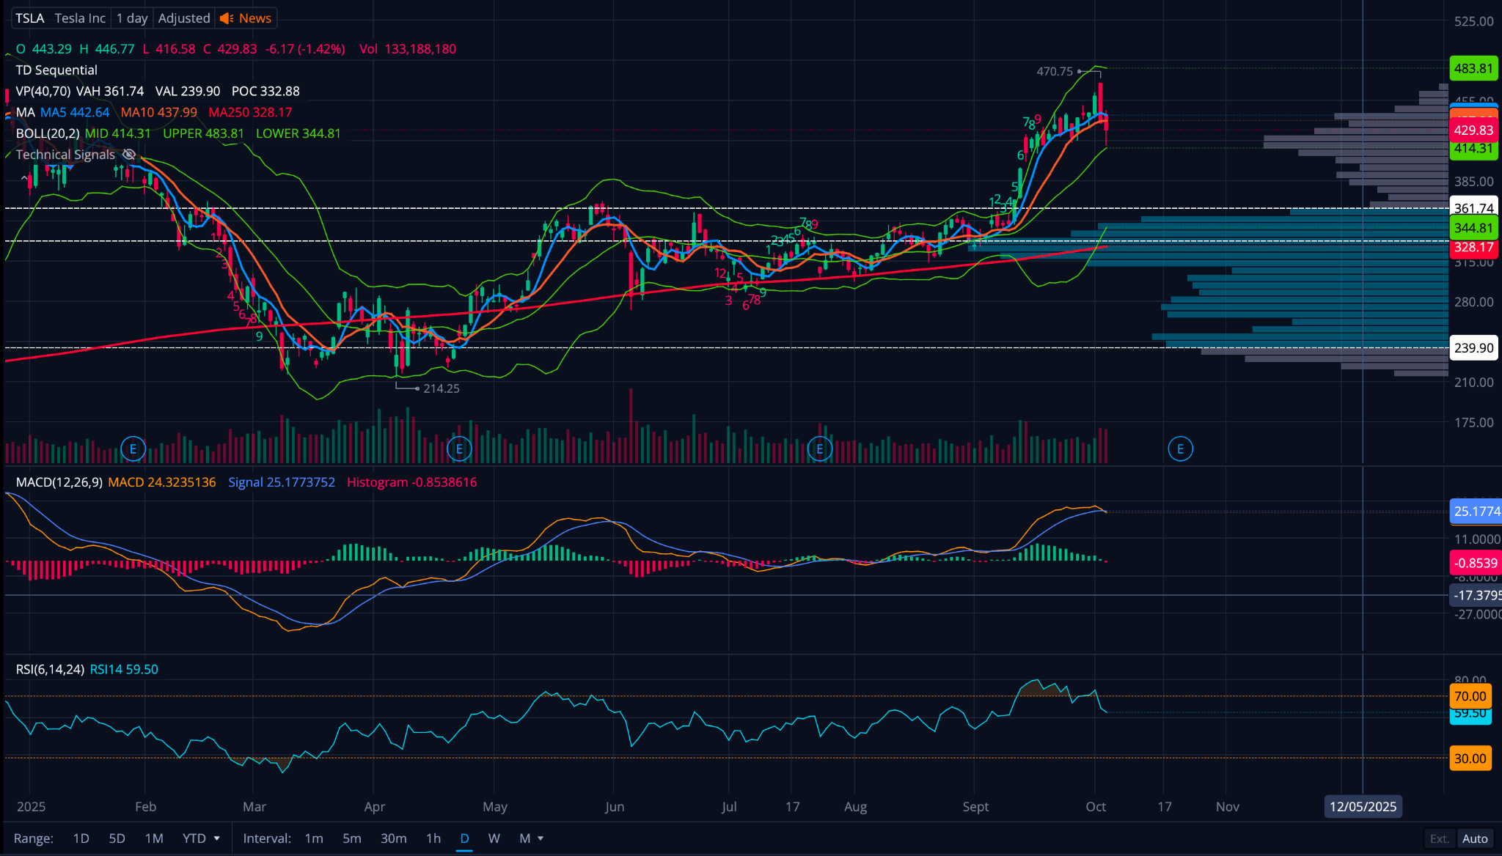
Response:
Looking at the attached TSLA daily chart, Tesla’s stock recently pulled back after peaking near $470, marking a short-term correction following a strong multi-month uptrend from its spring lows near $214. The price remains well above major moving averages (the 50-day around $442 and 200-day near $328), signaling an intact longer-term uptrend. The Bollinger Bands show price retreating from the upper band toward the midline around $414, suggesting short-term cooling after an overbought stretch. The MACD has started to roll over with the histogram turning negative, confirming waning bullish momentum, while the RSI (≈ 59) is neutral—neither overbought nor oversold—indicating room for further consolidation. Volume-by-price shows strong support near $345–$360, while resistance remains near the recent $470 high. Overall, Tesla is taking a healthy breather within a larger bullish trend; holding above $414 keeps the uptrend intact, but a break below $360 could signal deeper correction potential.
From a GenAI model perspective, the response demonstrates how an LLM can perform structured technical analysis by interpreting common chart indicators (price trend, moving averages, Bollinger Bands, MACD, RSI, and volume profile) into plain-language financial insight. The model integrates pattern recognition (trend direction, support/resistance) with signal interpretation (momentum, volatility, and strength) to produce a concise narrative resembling a human analyst’s commentary. It doesn’t “see” the chart as a human trader would, but rather infers meaning from described visual data, using domain knowledge about how each indicator behaves. The result is a coherent, data-driven summary that balances technical precision with natural-language clarity—illustrating how generative AI can convert quantitative visual information into actionable qualitative insight. I agree with its analysis based on review of the chart.
Batch Chart Analysis Only Based on Ticker Names
Prompt: Perform a deep-dive technical analysis on the attached stock tickers listed under the ‘Symbol’ column. For each ticker, analyze the chart pattern using moving averages (MA5, MA10, MA50, MA200), Bollinger Bands (BOLL), MACD, and RSI or other indicators. Explain whether the stock is in an uptrend, downtrend, or consolidation phase, and describe any notable technical signals such as ‘breaking above the middle Bollinger Band,’ ‘RSI showing upward momentum,’ or ‘MACD crossover indicating potential reversal.’ Summarize each ticker’s short-term and medium-term outlook in clear, natural language. Return table with two columns: Ticker and Analysis Summary (Up to 300 words) for each ticker.
Response (Top results):
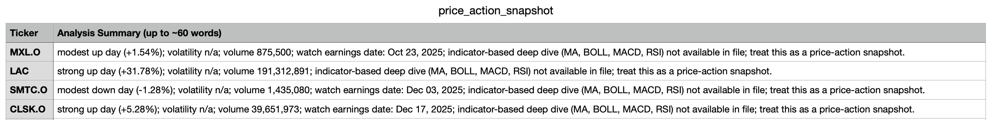
The response clearly shows limit of the GenAI to do deep dive analysis on ticker batch as it does not meet the requirement intended in the prompt; Instead, it simply repeats what’s already in the file and failed to do chart analysis as the indicators needed are not present in the file. This justified the need to derive the indicators from other means, such as the yahoo finance API.
Made-up Indicator Numbers to Json Stock Analysis
Prompt: Using the attached Excel file containing made-up technical indicators for 20 stocks, perform a detailed technical analysis for each ticker.
For every stock:
- Interpret the indicators (MA5, MA20, MA50, MA200, RSI, MACD, Bollinger Bands, ATR, ADX) to describe the current technical setup in natural language (up to 300 words per stock).
- Identify whether the stock is in a short-term or medium-term uptrend, downtrend, or consolidation phase.
- Mention notable signals such as breakouts above moving averages, RSI momentum shifts, MACD crossovers, or Bollinger Band squeezes/expansions.
- Conclude each analysis with an overall sentiment rating: Bullish, Bearish, or Neutral, and assign a score from 1 to 10 reflecting the strength of that sentiment (e.g., 9 = strong bullish, 5 = neutral, 2 = strong bearish).
Return the result as a table with three fields in Json:
Ticker, Analysis Summary (≤300 words), and Sentiment Score (1–10 with label).

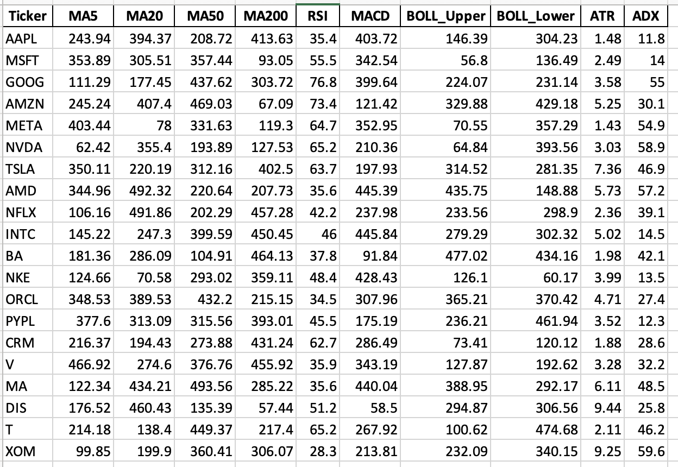
Response:
The response was as expected with the three key-value pairs for each ticker. See example below.
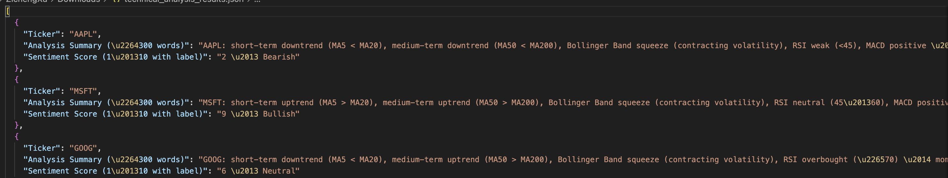
The results indicate the ability of GPT models to analyze the technical indicators the similar way it analyzes the charts of the tickers. Therefore, I will be able to derive major indicators from the yahoo finance API and drive chart analysis from there using GPT models.

Financial Indicators Extraction based on Tickers Only
Prompt: Using the attached Excel file containing stock tickers under the ‘Ticker’ column, retrieve and summarize key financial valuation metrics for each company.
For every ticker, provide the following indicators (using the most recent available data):
- P/E (Price-to-Earnings) ratio
- Forward P/E ratio
- P/B (Price-to-Book) ratio
- P/S (Price-to-Sales) ratio
- EPS (Earnings per Share, trailing 12 months)
- Forward EPS (next fiscal year)
- Dividend Yield (%)
- Market Cap (in billions USD)
- Revenue Growth (YoY %)
Present your response as a JSON table with these fields:
Ticker, P/E, Forward P/E, P/B, P/S, EPS (TTM), Forward EPS, Dividend Yield, Market Cap (B USD), and Revenue Growth (YoY %).
If data is not available for any field, mark it as null or "N/A". Use consistent decimal formatting and ensure all ratios are rounded to two decimals.
Response:
Although ChatGPT returned the Json file with all the fields requested, the numbers are not accurate and some are far off based on my sampling audit with Yahoo Finance and Stock Analysis (Stock Analysis, 2024).

Initial System Design

Data Acquisition
The system reads a CSV watchlist (129 tickers) that I exported from investing.com and normalizes symbols (e.g., SMTC.O → SMTC, BRK.B → BRK-B). Daily price data are retrieved from yfinance (free Yahoo Finance API).
Feature Engineering
I locally computed indicators include RSI, MACD, Bollinger Bands, %B, bandwidth, 52-week high/low, support/resistance, and TD Sequential setup counts.
Tagging & Local Scoring
Numeric values are converted into tags (e.g., RSI_oversold, MACD_bullish) and aggregated into a transparent score (−2 to +2).
GenAI Chart Analysis
Each ticker’s indicators are sent to OpenAI with a structured prompt. The model returns stance, score, and summary (in JSON).
Decision Blending
The final score = local_score + llm_score, which maps to Buy (≥ +2), Hold (−1 to +1), or Sell (≤ −2).
Output
A CSV table lists each ticker, technical fields, GenAI summary, and final decision.

Fine-Tuning Approach (Planned)
Going forward, I plan to move the project beyond OpenAI’s hosted models and instead use an open-source language model from Hugging Face that can be fine-tuned locally using a lightweight method called Low-Rank Adaptation (LoRA), as indicated in the requirement of the project. This approach allows the system to learn from its own chart data and past GenAI summaries without needing massive computing power. I plan to select a smaller instruction-tuned model, such as Mistral or LLaMA, and train it on examples built from the indicators and AI outputs already generated in the steps of the Jupyter notebook. Each example will pair the stock’s technical readings—like RSI, MACD, and support levels—with the correct short explanation and stance (bullish, bearish, or neutral). By training a LoRA adapter on these examples, the model will learn how to recognize chart patterns and describe them in clear language. Afterward, the model will run locally and produce its own chart analyses and stance scores at no ongoing API cost, if that’s what’s required by the Professor. This method is cost-efficient, transparent, and customizable, allowing me to refine the model gradually as more labeled data are collected in future milestones.

Conclusion
This milestone expanded the original stock-catalyst idea into a fully integrated Generative AI system that interprets market data, computes technical indicators, and delivers clear, human-readable chart analyses. Through the combination of rule-based scoring and LLM reasoning, the project now bridges the gap between quantitative trading signals and intuitive insight—something that ordinary data tools cannot provide. The design remains cost-efficient by relying on free data sources such as Yahoo Finance while selectively using GPT-4o-mini for interpretive reasoning. Moving forward, fine-tuning an open-source model through the Hugging Face and LoRA framework will make the assistant more independent, customizable, and reproducible without paid APIs. This next phase will allow the system to learn from its own labeled examples and continuously improve its technical-analysis fluency. Overall, the project demonstrates a practical, explainable, and scalable use of generative AI for financial analytics and sets the stage for future milestones focused on dashboard visualization and model fine-tuning evaluation.

References
OpenAI. (2024). GPT-4 technical report. https://openai.com/research/gpt-4
Stock Analysis. (2024). Apple Inc. (AAPL) Financial Ratios and Metrics. Stock Analysis. https://stockanalysis.com/stocks/aapl/financials/ratios/
Yahoo Finance. (2025). YFinance API documentation. https://pypi.org/project/yfinance

